**NOS-120 Chapter 7**

Log into NDG and workstation virtual Classroom Machine to complete this quiz.

**Note: Before you begin this quiz create a directory named Quiz7. Within that directory use the touch command to create five empty files named demo1, demo2, demo3, demo4, and demo5. Then create a group named Project1 and create a user named Tom.**

1. Type the command with the appropriate option to set permissions for demo1 and demo2. Once complete run the **ll** command to verify.

**User: read & write Group: read & write Other: none**

Insert Screenshot Below:

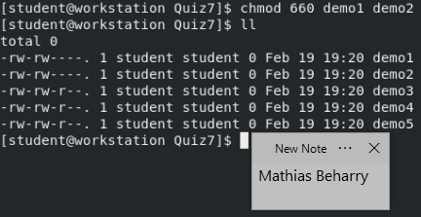

1. Type the command with the appropriate options to change the owner of demo3 to Tom and the group to Project1. Once complete run the **ll** command to verify.

Insert Screenshot Below:

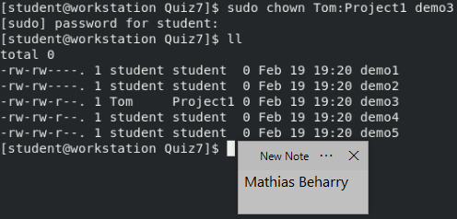

1. Go to the home directory for the user student.

Type the command with the appropriate option to set the group for the directory Quiz7 and all contents of that directory to Project1. Once complete run the ll command against the Quiz7 directory to verify**.**

Insert Screenshot Below:

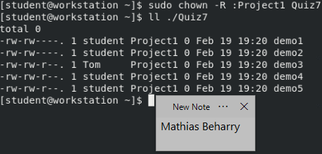

1. Go to the home directory for the user student. Type the command with the appropriate option to set the special permission for the directory Quiz7 so that files newly created in the directory have their group owner set to match the group owner of the directory. Once complete run the ll command from the students home directory. (*You should see the s added to the group permissions*)

Insert Screenshot Below:

